Roman Numeral System
# Source: AI Source: Provided by: [Data Path: Persons Table -> ID Column: 1, Name_En Column: Motasem Essam] -> From: [ChatGPT] on [7/16/2026]
The Roman Numeral System is a non-positional numeral system developed in ancient Rome. It represents numbers using combinations of letters from the Latin alphabet, where each symbol has a fixed numerical value regardless of its position.
Unlike modern positional numeral systems (such as decimal or binary), Roman numerals do not use place value or a base (radix). Numbers are formed by combining symbols according to rules of addition and subtraction.
Roman numerals are still used today for clock faces, book chapters, monarchs, movie sequels, sporting events, and ceremonial numbering.

Definition
# Source: AI Source: Provided by: [Data Path: Persons Table -> ID Column: 1, Name_En Column: Motasem Essam] -> From: [ChatGPT] on [7/16/2026]
The Roman Numeral System is a non-positional numeral system in which numbers are represented by combinations of symbols with fixed values.
Each symbol always represents the same value, regardless of its position.

Type of Numeral System
# Source: AI Source: Provided by: [Data Path: Persons Table -> ID Column: 1, Name_En Column: Motasem Essam] -> From: [ChatGPT] on [7/16/2026]
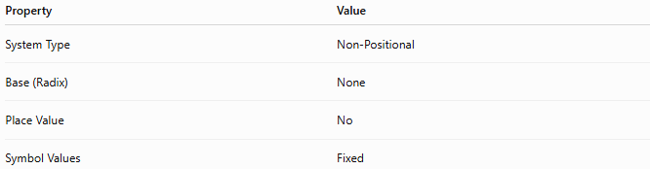
Property | Value
System Type | Non-Positional
Base (Radix) | None
Place Value | No
Symbol Values | Fixed

Roman Numeral Symbols
# Source: AI Source: Provided by: [Data Path: Persons Table -> ID Column: 1, Name_En Column: Motasem Essam] -> From: [ChatGPT] on [7/16/2026]
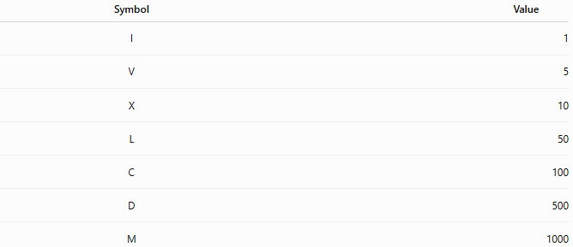
Symbol | Value
I | 1
V | 5
X | 10
L | 50
C | 100
D | 500
M | 1000

Basic Principle
# Source: AI Source: Provided by: [Data Path: Persons Table -> ID Column: 1, Name_En Column: Motasem Essam] -> From: [ChatGPT] on [7/16/2026]
Roman numerals are formed by combining symbols according to established rules.
The value is determined by:
- Addition
- Subtraction
There is no positional value.

Addition Rule
# Source: AI Source: Provided by: [Data Path: Persons Table -> ID Column: 1, Name_En Column: Motasem Essam] -> From: [ChatGPT] on [7/16/2026]
When a symbol of equal or smaller value follows another symbol, the values are added.
Examples:
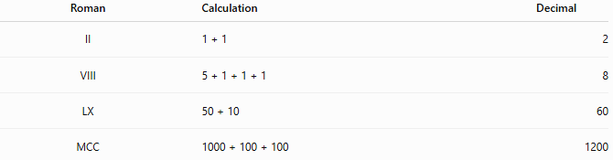
Roman | Calculation | Decimal
II | 1 + 1 | 2
VIII | 5 + 1 + 1 + 1 | 8
LX | 50 + 10 | 60
MCC | 1000 + 100 + 100 | 1200

Subtraction Rule
# Source: AI Source: Provided by: [Data Path: Persons Table -> ID Column: 1, Name_En Column: Motasem Essam] -> From: [ChatGPT] on [7/16/2026]
When a smaller symbol appears before a larger one, its value is subtracted.
Only specific subtractive combinations are valid.
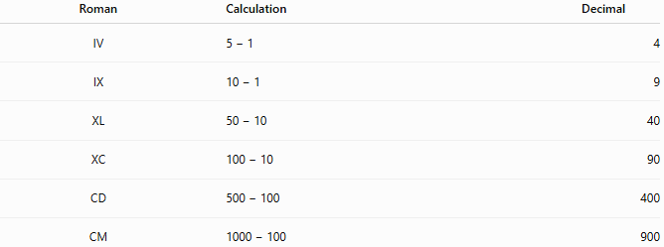
Roman | Calculation | Decimal
IV | 5 − 1 | 4
IX | 10 − 1 | 9
XL | 50 − 10 | 40
XC | 100 − 10 | 90
CD | 500 − 100 | 400
CM | 1000 − 100 | 900

Roman Numeral Table
# Source: AI Source: Provided by: [Data Path: Persons Table -> ID Column: 1, Name_En Column: Motasem Essam] -> From: [ChatGPT] on [7/16/2026]
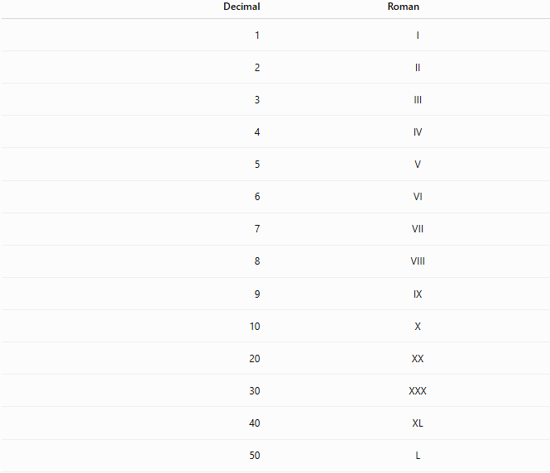

Decimal | Roman
1 | I
2 | II
3 | III
4 | IV
5 | V
6 | VI
7 | VII
8 | VIII
9 | IX
10 | X
20 | XX
30 | XXX
40 | XL
50 | L
90 | XC
100 | C
400 | CD
500 | D
900 | CM
1000 | M

Examples
# Source: AI Source: Provided by: [Data Path: Persons Table -> ID Column: 1, Name_En Column: Motasem Essam] -> From: [ChatGPT] on [7/16/2026]
Example 1
Roman numeral
$$XIV$$
Calculation
$$10+(5-1)=14$$

Example 2
Roman numeral
$$XXVII$$
Calculation
$$10+10+5+1+1=27$$

Example 3
Roman numeral
$$MCMLXXXIV$$
Calculation
$$1000+900+50+30+4=1984$$

Example 4
Roman numeral
$$MMXXVI$$
Calculation
$$1000+1000+10+10+5+1=2026$$

Writing Rules
# Source: AI Source: Provided by: [Data Path: Persons Table -> ID Column: 1, Name_En Column: Motasem Essam] -> From: [ChatGPT] on [7/16/2026]
Symbols that may repeat
These symbols may be repeated up to three times:
- I
- X
- C
- M
Examples
$$III=3 \\ XXX=30$$

Symbols that do not repeat
The following symbols are generally not repeated:
- V
- L
- D

Allowed subtraction pairs
# Source: AI Source: Provided by: [Data Path: Persons Table -> ID Column: 1, Name_En Column: Motasem Essam] -> From: [ChatGPT] on [7/16/2026]
Only these subtractive pairs are valid:

Smaller | Larger
I | V, X
X | L, C
C | D, M
Examples
$$IV, IX, XL, XC, CD, CM$$

Characteristics
# Source: AI Source: Provided by: [Data Path: Persons Table -> ID Column: 1, Name_En Column: Motasem Essam] -> From: [ChatGPT] on [7/16/2026]
The Roman numeral system:
- Is non-positional.
- Has no place value.
- Has no base (radix).
- Uses fixed-value symbols.
- Uses addition and subtraction rules.
- Does not include a symbol for zero.
- Traditionally has no standard notation for negative numbers.

Advantages
# Source: AI Source: Provided by: [Data Path: Persons Table -> ID Column: 1, Name_En Column: Motasem Essam] -> From: [ChatGPT] on [7/16/2026]
The Roman numeral system:
- Is easy to recognize for small numbers.
- Has historical and cultural significance.
- Is widely used in ceremonial contexts.
- Is visually distinctive.

Disadvantages
# Source: AI Source: Provided by: [Data Path: Persons Table -> ID Column: 1, Name_En Column: Motasem Essam] -> From: [ChatGPT] on [7/16/2026]
The Roman numeral system:
- Is inefficient for very large numbers.
- Has no place-value structure.
- Does not naturally represent zero or decimals.
- Makes arithmetic calculations difficult.
- Is unsuitable for modern scientific and computational work.

Applications
# Source: AI Source: Provided by: [Data Path: Persons Table -> ID Column: 1, Name_En Column: Motasem Essam] -> From: [ChatGPT] on [7/16/2026]
Roman numerals are used in:
- Clock faces
- Book chapters
- Movie sequels
- Monarch names
- Sporting events
- Building cornerstones
- Historical documents
- Copyright years
- Outlines and lists
- Monument inscriptions

Real-Life Applications
# Source: AI Source: Provided by: [Data Path: Persons Table -> ID Column: 1, Name_En Column: Motasem Essam] -> From: [ChatGPT] on [7/16/2026]
Examples include:
- King Charles III
- Pope John Paul II
- World War II
- Super Bowl LVIII
- Chapter XII
- Clock showing IV for 4

Common Mistakes
# Source: AI Source: Provided by: [Data Path: Persons Table -> ID Column: 1, Name_En Column: Motasem Essam] -> From: [ChatGPT] on [7/16/2026]
- Repeating V, L, or D.
- Using invalid subtraction such as IL for 49 (correct: XLIX).
- Assuming Roman numerals use place value.
- Thinking Roman numerals have a base like decimal or binary.

Key Points
# Source: AI Source: Provided by: [Data Path: Persons Table -> ID Column: 1, Name_En Column: Motasem Essam] -> From: [ChatGPT] on [7/16/2026]
- Roman numerals are non-positional.
- Each symbol has a fixed value.
- Numbers are formed using addition and subtraction.
- There is no place-value system.
- Roman numerals remain widely used for historical and ceremonial purposes.

Roman Numerals vs. Decimal Numerals
# Source: AI Source: Provided by: [Data Path: Persons Table -> ID Column: 1, Name_En Column: Motasem Essam] -> From: [ChatGPT] on [7/16/2026]
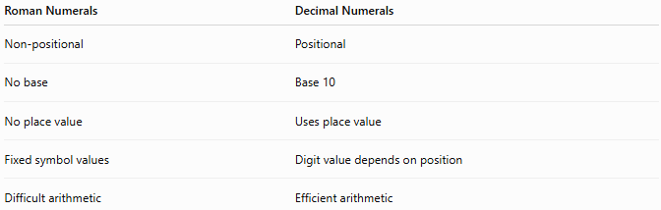
Roman Numerals | Decimal Numerals
Non-positional | Positional
No base | Base 10
No place value | Uses place value
Fixed symbol values | Digit value depends on position
Difficult arithmetic | Efficient arithmetic

Roman Numerals vs. Binary
# Source: AI Source: Provided by: [Data Path: Persons Table -> ID Column: 1, Name_En Column: Motasem Essam] -> From: [ChatGPT] on [7/16/2026]
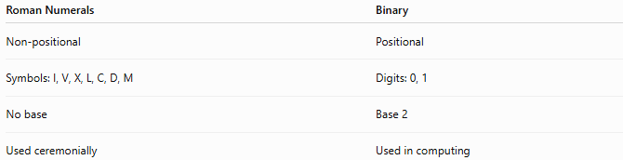
Roman Numerals | Binary
Non-positional | Positional
Symbols: I, V, X, L, C, D, M | Digits: 0, 1
No base | Base 2
Used ceremonially | Used in computing

Roman Numerals vs. Hexadecimal
# Source: AI Source: Provided by: [Data Path: Persons Table -> ID Column: 1, Name_En Column: Motasem Essam] -> From: [ChatGPT] on [7/16/2026]
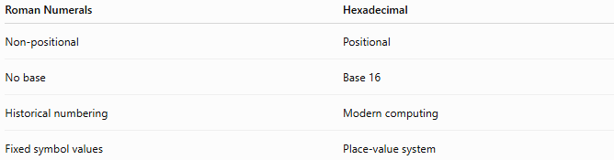
Roman Numerals | Hexadecimal
Non-positional | Positional
No base | Base 16
Historical numbering | Modern computing
Fixed symbol values | Place-value system

Conclusion
# Source: AI Source: Provided by: [Data Path: Persons Table -> ID Column: 1, Name_En Column: Motasem Essam] -> From: [ChatGPT] on [7/16/2026]
The Roman Numeral System is a non-positional numeral system that represents numbers using combinations of the symbols I, V, X, L, C, D, and M, each with a fixed numerical value. It does not use place value or a base, relying instead on rules of addition and subtraction to form numbers. Although it has been replaced by positional numeral systems for mathematics and computation, Roman numerals remain an important part of history and continue to be used in clocks, book chapters, monarch names, sporting events, and ceremonial numbering.

